Functional Model
By
Vamshi Udari

1. Use case Diagram
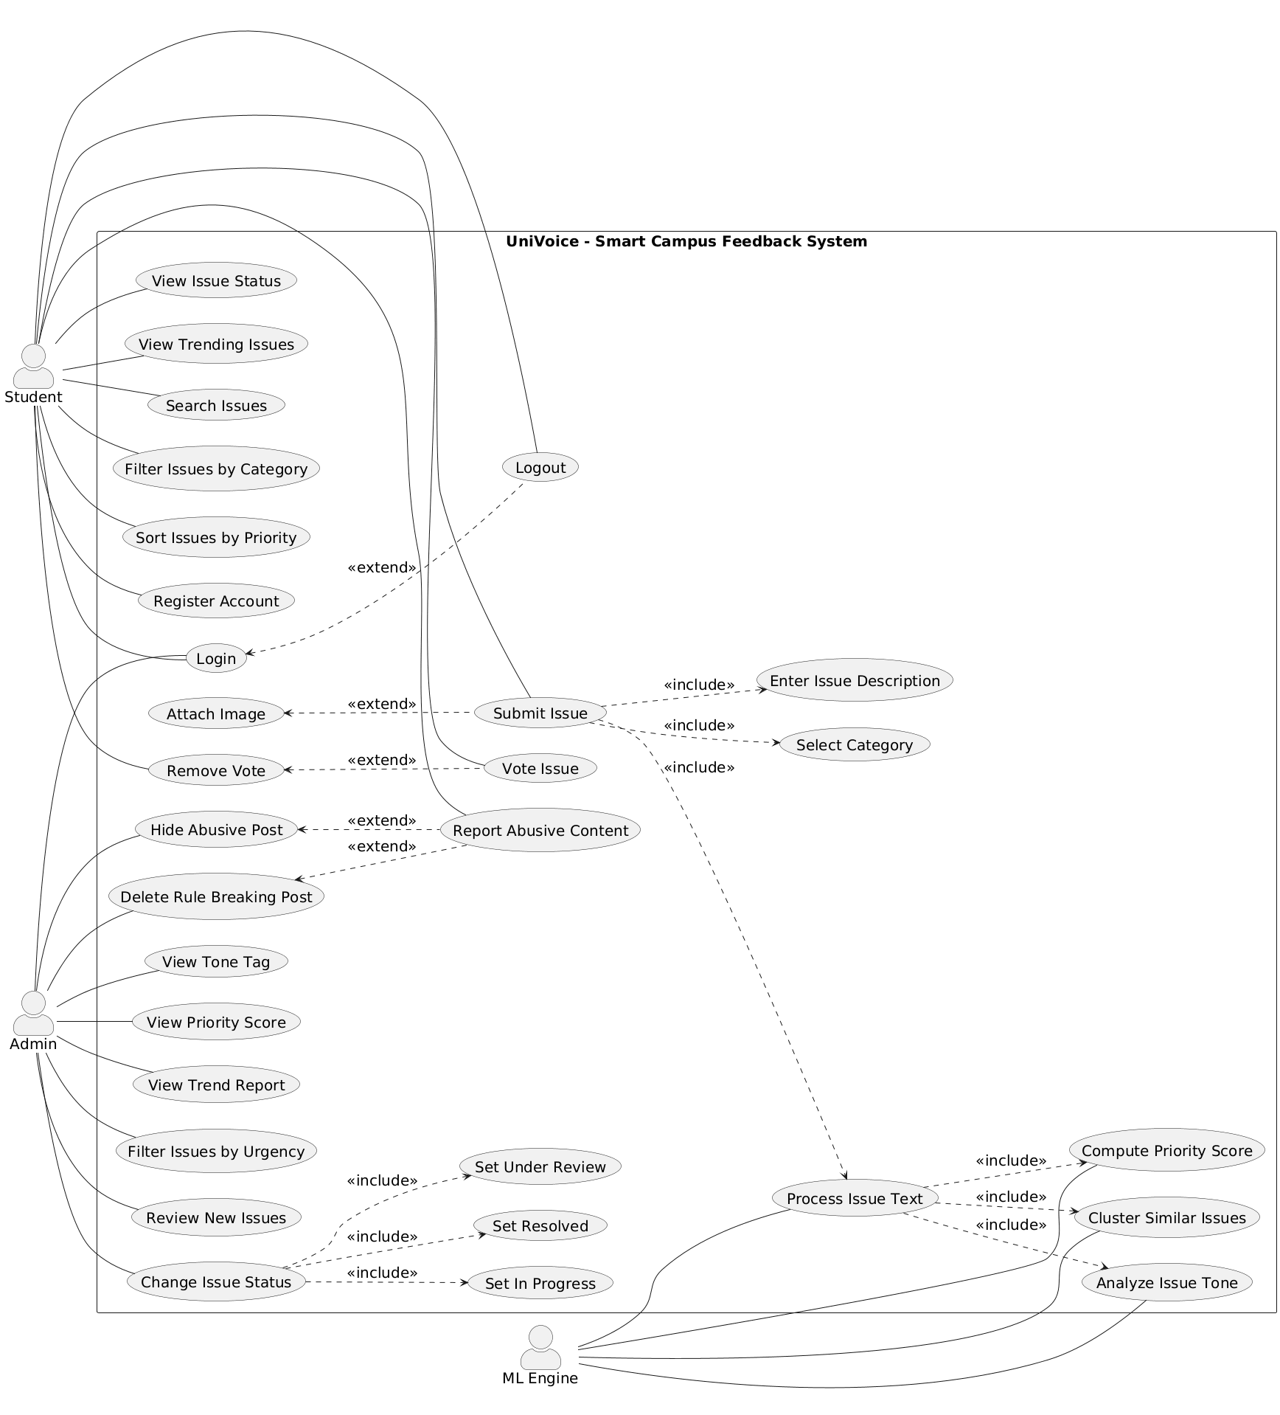
Figure.1 Use Case Diagram

2. Use Case Descriptions

Use Case 1 – View Issue Status
Use Case No. | 1
Use Case Name | View Issue Status
Primary Actor | Student
Supporting Actor | System
Trigger | Student selects an issue to check its current status.
Pre-Conditions | Student is logged into the system.
Post-Conditions | The current status of the issue is shown to the student.
Normal Flow | 1. Student opens the issue list.  2. Student selects an issue.  3. System displays the issue status (new, under review, in progress, resolved).
Exception Flow | If the issue is deleted or hidden, the system shows a message that the issue is not available.
Related Requirements | FR: Student can view issue status.
Include / Extend | Includes Login.

Use Case 2 – View Trending Issues
Use Case No. | 2
Use Case Name | View Trending Issues
Primary Actor | Student
Supporting Actor | System
Trigger | Student selects the option to view trending issues.
Pre-Conditions | Student is logged into the system.
Post-Conditions | Trending issues are displayed based on priority and activity.
Normal Flow | 1. Student clicks on trending issues.  2. System fetches high priority issues.  3. System shows the trending list.
Exception Flow | If no trending issues exist, system shows an empty list message.
Related Requirements | FR: Student can view trending issues.
Include / Extend | Includes Login.

Use Case 3 – Search Issues
Use Case No. | 3
Use Case Name | Search Issues
Primary Actor | Student
Supporting Actor | System
Trigger | Student enters keywords in the search box.
Pre-Conditions | Student is logged into the system.
Post-Conditions | Matching issues are displayed.
Normal Flow | 1. Student types keywords.  2. Student clicks search.  3. System displays matching issues.
Exception Flow | If no match is found, system shows “No results found.”
Related Requirements | FR: Student can search issues using keywords.
Include / Extend | Includes Login.

Use Case 4 – Filter Issues by Category
Use Case No. | 4
Use Case Name | Filter Issues by Category
Primary Actor | Student
Supporting Actor | System
Trigger | Student selects a category filter.
Pre-Conditions | Student is logged into the system.
Post-Conditions | Issues are filtered by selected category.
Normal Flow | 1. Student selects a category.  2. System filters issues by category.  3. System shows filtered results.
Exception Flow | If no issues match the category, system shows empty result message.
Related Requirements | FR: Student can filter issues by category.
Include / Extend | Includes Login.

Use Case 5 – Sort Issues by Priority
Use Case No. | 5
Use Case Name | Sort Issues by Priority
Primary Actor | Student
Supporting Actor | System
Trigger | Student selects sort by priority option.
Pre-Conditions | Student is logged into the system.
Post-Conditions | Issues are displayed in priority order.
Normal Flow | 1. Student selects sort by priority.  2. System orders issues using priority score.  3. Sorted list is displayed.
Exception Flow | If priority data is unavailable, system shows default order.
Related Requirements | FR: Student can sort issues by priority score.
Include / Extend | Includes Login.

Use Case 6 – Register Account
Use Case No. | 6
Use Case Name | Register Account
Primary Actor | Student
Supporting Actor | System
Trigger | Student clicks the register option on the login page.
Pre-Conditions | Student is not logged into the system.
Post-Conditions | A new student account is created in the system.
Normal Flow | 1. Student opens the registration page.  2. Student enters email and password.  3. Student submits the form.  4. System validates the details.  5. System creates the account.
Exception Flow | If email already exists or details are invalid, the system shows an error message.
Related Requirements | FR: Student can register profile using email and password.
Include / Extend | May include Login after successful registration.

Use Case 7 – Login
Use Case No. | 7
Use Case Name | Login
Primary Actor | Student / Admin
Supporting Actor | System
Trigger | User enters login credentials and clicks login.
Pre-Conditions | User has a valid registered account.
Post-Conditions | User is logged into the system successfully.
Normal Flow | 1. User enters email and password.  2. User clicks login.  3. System verifies credentials.  4. System allows access to the dashboard.
Exception Flow | If credentials are incorrect, the system shows an error message.
Related Requirements | FR: Student can log in using registered credentials.  FR: Admin can log in using secure credentials.
Include / Extend | Included by most use cases that require authentication.

Use Case 8 – Logout
Use Case No. | 8
Use Case Name | Logout
Primary Actor | Student / Admin
Supporting Actor | System
Trigger | User clicks the logout option.
Pre-Conditions | User is logged into the system.
Post-Conditions | User session is ended and user is logged out.
Normal Flow | 1. User clicks logout.  2. System ends the session.  3. System redirects to the login page.
Exception Flow | If session already expired, system redirects to login page.
Related Requirements | FR: Student can log out from system.  FR: Admin can log out from system.
Include / Extend | Extends Login (Logout is possible only after login).

Use Case 9 – Submit Issue
Use Case No. | 9
Use Case Name | Submit Issue
Primary Actor | Student
Supporting Actor | System, ML Engine
Trigger | Student clicks the submit issue button.
Pre-Conditions | Student is logged into the system.
Post-Conditions | Issue is saved and sent for processing.
Normal Flow | 1. Student opens submit issue form.  2. Student selects a category.  3. Student enters issue description.  4. Student submits the issue.  5. System saves the issue.  6. System sends issue text for processing.
Exception Flow | If required fields are missing, system shows validation error.
Related Requirements | FR: Student can submit issue anonymously.  FR: Student can select category.  FR: Student can enter issue description.
Include / Extend | Includes Select Category, Enter Issue Description, Process Issue Text.  Attach Image extends this use case.

Use Case 10 – Enter Issue Description
Use Case No. | 10
Use Case Name | Enter Issue Description
Primary Actor | Student
Supporting Actor | System
Trigger | Student types issue details in the text box.
Pre-Conditions | Student has started the submit issue process.
Post-Conditions | Issue description is captured by the system.
Normal Flow | 1. Student types the issue description.  2. System records the text input.
Exception Flow | If description is empty, system shows an error message.
Related Requirements | FR: Student can enter issue description in text field.
Include / Extend | Included by Submit Issue.

Use Case 11 – Select Category
Use Case No. | 11
Use Case Name | Select Category
Primary Actor | Student
Supporting Actor | System
Trigger | Student selects a category from the list while submitting an issue.
Pre-Conditions | Student has opened the submit issue form.
Post-Conditions | The selected category is saved with the issue.
Normal Flow | 1. Student views category options.  2. Student selects one category.  3. System stores the selected category.
Exception Flow | If no category is selected, system asks the student to choose a category.
Related Requirements | FR: Student can select category during issue submit.
Include / Extend | Included by Submit Issue.

Use Case 12 – Attach Image
Use Case No. | 12
Use Case Name | Attach Image
Primary Actor | Student
Supporting Actor | System
Trigger | Student chooses to attach an image with the issue.
Pre-Conditions | Student has started submitting an issue.
Post-Conditions | The image is uploaded and attached to the issue.
Normal Flow | 1. Student clicks attach image.  2. Student selects an image file.  3. System uploads and links the image to the issue.
Exception Flow | If the file type or size is invalid, system shows an error message.
Related Requirements | FR: Student can attach single image with issue.
Include / Extend | Extends Submit Issue.

Use Case 13 – Vote Issue
Use Case No. | 13
Use Case Name | Vote Issue
Primary Actor | Student
Supporting Actor | System
Trigger | Student clicks the vote button on an issue.
Pre-Conditions | Student is logged into the system and viewing an issue.
Post-Conditions | The vote count for the issue is increased.
Normal Flow | 1. Student opens an issue.  2. Student clicks vote.  3. System records the vote and updates the count.
Exception Flow | If student has already voted, system shows a message and blocks duplicate voting.
Related Requirements | FR: Student can vote issue.
Include / Extend | Includes Login.

Use Case 14 – Remove Vote
Use Case No. | 14
Use Case Name | Remove Vote
Primary Actor | Student
Supporting Actor | System
Trigger | Student clicks remove vote on an issue.
Pre-Conditions | Student has already voted on the issue.
Post-Conditions | The vote is removed and vote count is decreased.
Normal Flow | 1. Student opens the issue.  2. Student clicks remove vote.  3. System removes the vote and updates the count.
Exception Flow | If the student has not voted before, system shows an error message.
Related Requirements | FR: Student can remove vote from issue.
Include / Extend | Extends Vote Issue.

Use Case 15 – Report Abusive Content
Use Case No. | 15
Use Case Name | Report Abusive Content
Primary Actor | Student
Supporting Actor | System
Trigger | Student reports an issue as abusive or harmful.
Pre-Conditions | Student is logged into the system and viewing an issue.
Post-Conditions | The report is saved and sent to admin for review.
Normal Flow | 1. Student opens an issue.  2. Student clicks report abuse.  3. Student selects a reason.  4. System saves the report.
Exception Flow | If report submission fails, system shows an error message.
Related Requirements | FR: Student can report abusive content.
Include / Extend | Includes Login.

Use Case 16 – Review New Issues
Use Case No. | 16
Use Case Name | Review New Issues
Primary Actor | Admin
Supporting Actor | System
Trigger | Admin opens the new issues review page.
Pre-Conditions | Admin is logged into the system.
Post-Conditions | A list of new issues is displayed to the admin.
Normal Flow | 1. Admin opens the review page.  2. System loads new issues.  3. System displays the list to admin.
Exception Flow | If there are no new issues, system shows a message.
Related Requirements | FR: Admin can review new issues.
Include / Extend | Includes Login.

Use Case 17 – Change Issue Status
Use Case No. | 17
Use Case Name | Change Issue Status
Primary Actor | Admin
Supporting Actor | System
Trigger | Admin selects an option to change the status of an issue.
Pre-Conditions | Admin is logged into the system and viewing an issue.
Post-Conditions | The issue status is updated in the system.
Normal Flow | 1. Admin opens an issue.  2. Admin selects a new status.  3. System saves the updated status.
Exception Flow | If update fails, system shows an error message.
Related Requirements | FR: Admin can change issue status to under review, in progress, or resolved.
Include / Extend | Includes Set Under Review, Set In Progress, Set Resolved.

Use Case 18 – Set Under Review
Use Case No. | 18
Use Case Name | Set Under Review
Primary Actor | Admin
Supporting Actor | System
Trigger | Admin selects “Under Review” status for an issue.
Pre-Conditions | Admin is changing the issue status.
Post-Conditions | The issue status is updated to under review.
Normal Flow | 1. Admin selects “Under Review.”  2. System updates the issue status.
Exception Flow | If the update fails, system shows an error message.
Related Requirements | FR: Admin can change issue status to under review.
Include / Extend | Included by Change Issue Status.

Use Case 19 – Set In Progress
Use Case No. | 19
Use Case Name | Set In Progress
Primary Actor | Admin
Supporting Actor | System
Trigger | Admin selects “In Progress” status for an issue.
Pre-Conditions | Admin is changing the issue status.
Post-Conditions | The issue status is updated to in progress.
Normal Flow | 1. Admin selects “In Progress.”  2. System updates the issue status.
Exception Flow | If the update fails, system shows an error message.
Related Requirements | FR: Admin can change issue status to in progress.
Include / Extend | Included by Change Issue Status.

Use Case 20 – Set Resolved
Use Case No. | 20
Use Case Name | Set Resolved
Primary Actor | Admin
Supporting Actor | System
Trigger | Admin selects “Resolved” status for an issue.
Pre-Conditions | Admin is changing the issue status.
Post-Conditions | The issue status is updated to resolved.
Normal Flow | 1. Admin selects “Resolved.”  2. System updates the issue status.
Exception Flow | If the update fails, system shows an error message.
Related Requirements | FR: Admin can change issue status to resolved.
Include / Extend | Included by Change Issue Status.

Use Case 21 – Hide Abusive Post
Use Case No. | 21
Use Case Name | Hide Abusive Post
Primary Actor | Admin
Supporting Actor | System
Trigger | Admin chooses to hide a reported abusive post.
Pre-Conditions | Admin is logged in and a post has been reported.
Post-Conditions | The post is hidden from student view.
Normal Flow | 1. Admin opens the reported content list.  2. Admin selects a post to hide.  3. System hides the post from public view.
Exception Flow | If the post is not found or action fails, system shows an error message.
Related Requirements | FR: Admin can hide abusive posts.
Include / Extend | Extends Report Abusive Content.

Use Case 22 – Delete Rule Breaking Post
Use Case No. | 22
Use Case Name | Delete Rule Breaking Post
Primary Actor | Admin
Supporting Actor | System
Trigger | Admin chooses to delete a post that breaks rules.
Pre-Conditions | Admin is logged in and a post has been reported.
Post-Conditions | The post is permanently removed from the system.
Normal Flow | 1. Admin opens the reported content list.  2. Admin selects a post to delete.  3. System deletes the post.
Exception Flow | If deletion fails, system shows an error message.
Related Requirements | FR: Admin can delete posts breaking rules.
Include / Extend | Extends Report Abusive Content.

Use Case 23 – View Tone Tag
Use Case No. | 23
Use Case Name | View Tone Tag
Primary Actor | Admin
Supporting Actor | System
Trigger | Admin opens an issue to view its tone label.
Pre-Conditions | Admin is logged into the system.
Post-Conditions | The tone tag (negative, neutral, urgent) is displayed.
Normal Flow | 1. Admin opens an issue.  2. System displays the tone tag for the issue.
Exception Flow | If tone tag is not available, system shows a message.
Related Requirements | FR: Admin can view tone tag per issue.
Include / Extend | Includes Login.

Use Case 24 – View Priority Score
Use Case No. | 24
Use Case Name | View Priority Score
Primary Actor | Admin
Supporting Actor | System
Trigger | Admin opens an issue to view its priority score.
Pre-Conditions | Admin is logged into the system.
Post-Conditions | The priority score is displayed for the issue.
Normal Flow | 1. Admin opens an issue.  2. System shows the priority score.
Exception Flow | If score is not available, system shows an error message.
Related Requirements | FR: Admin can view priority score per issue.
Include / Extend | Includes Login.

Use Case 25 – View Trend Report
Use Case No. | 25
Use Case Name | View Trend Report
Primary Actor | Admin
Supporting Actor | System
Trigger | Admin selects the trend report option.
Pre-Conditions | Admin is logged into the system.
Post-Conditions | Trend report for selected date range is displayed.
Normal Flow | 1. Admin selects date range.  2. System generates the trend report.  3. System displays the report.
Exception Flow | If no data is available, system shows a message.
Related Requirements | FR: Admin can view trend report by date range.
Include / Extend | Includes Login.

Use Case 26 – Filter Issues by Urgency
Use Case No. | 26
Use Case Name | Filter Issues by Urgency
Primary Actor | Admin
Supporting Actor | System
Trigger | Admin selects the urgency filter option.
Pre-Conditions | Admin is logged into the system.
Post-Conditions | Issues are filtered and displayed based on urgency level.
Normal Flow | 1. Admin selects urgency level (urgent/normal).  2. System filters issues by selected urgency.  3. System displays filtered issues.
Exception Flow | If no issues match the filter, system shows an empty result message.
Related Requirements | FR: Admin can filter issues by urgency.
Include / Extend | Includes Login.

Use Case 27 – Process Issue Text
Use Case No. | 27
Use Case Name | Process Issue Text
Primary Actor | ML Engine
Supporting Actor | System
Trigger | A new issue is submitted by a student.
Pre-Conditions | Issue text is available in the system.
Post-Conditions | Issue text is processed and prepared for analysis.
Normal Flow | 1. System sends issue text to ML engine.  2. ML engine converts text into vectors.  3. System receives processed text data.
Exception Flow | If text processing fails, system logs the error and marks issue for retry.
Related Requirements | FR: System converts issue text into TF-IDF vectors.
Include / Extend | Included by Submit Issue.

Use Case 28 – Compute Priority Score
Use Case No. | 28
Use Case Name | Compute Priority Score
Primary Actor | ML Engine
Supporting Actor | System
Trigger | Issue text processing is completed.
Pre-Conditions | Vote count and cluster frequency are available.
Post-Conditions | Priority score is calculated and stored for the issue.
Normal Flow | 1. System collects vote count and cluster frequency.  2. ML engine applies the priority formula.  3. System saves the computed score.
Exception Flow | If calculation fails, system logs the error and uses default score.
Related Requirements | FR: System computes priority score using formula.
Include / Extend | Included by Process Issue Text.

Use Case 29 – Cluster Similar Issues
Use Case No. | 29
Use Case Name | Cluster Similar Issues
Primary Actor | ML Engine
Supporting Actor | System
Trigger | New issue text is processed.
Pre-Conditions | TF-IDF vectors are available.
Post-Conditions | Similar issues are grouped into clusters.
Normal Flow | 1. ML engine runs clustering on vectors.  2. System groups issues into topics.
Exception Flow | If clustering fails, system logs the error and retries later.
Related Requirements | FR: System clusters similar issues using K-Means algorithm.
Include / Extend | Included by Process Issue Text.

Use Case 30 – Analyze Issue Tone
Use Case No. | 30
Use Case Name | Analyze Issue Tone
Primary Actor | ML Engine
Supporting Actor | System
Trigger | Issue text is available for sentiment analysis.
Pre-Conditions | Issue text is processed.
Post-Conditions | Tone label (negative, neutral, urgent) is assigned to the issue.
Normal Flow | 1. ML engine analyzes issue text using sentiment model.  2. System stores the tone label for the issue.
Exception Flow | If sentiment analysis fails, system marks tone as unknown and logs the error.
Related Requirements | FR: System analyzes issue tone using VADER sentiment model.
Include / Extend | Included by Process Issue Text.

3. Activity Diagram
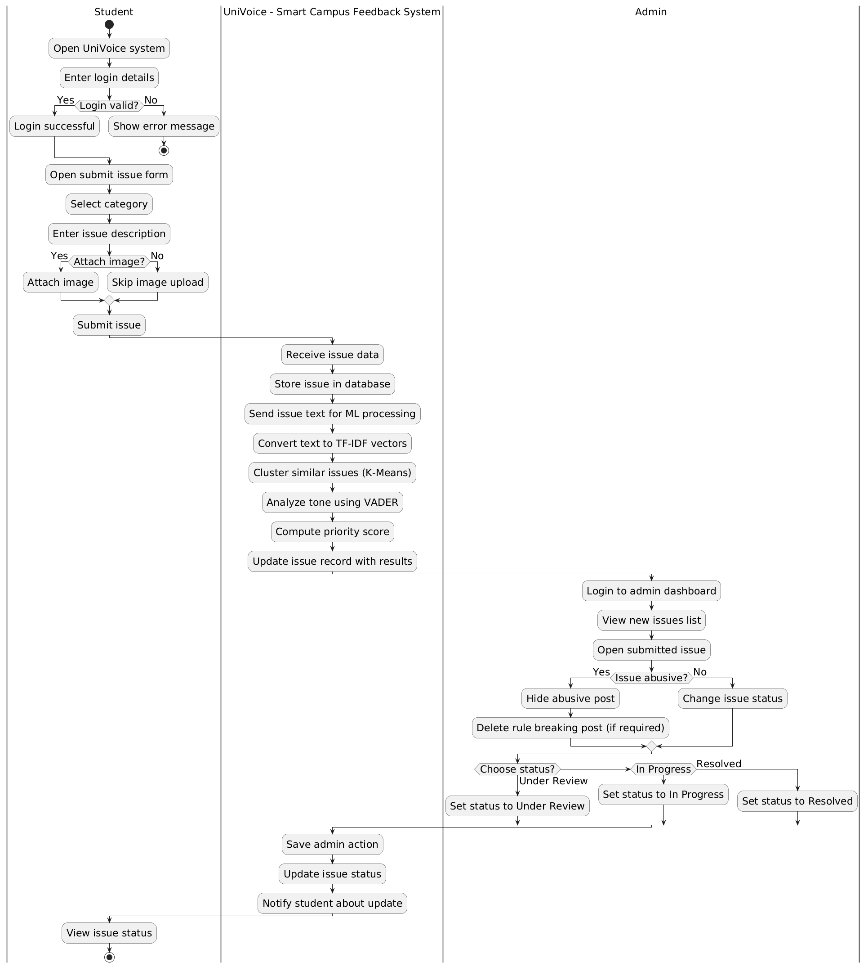
Figure.2 Activity Diagram

